______________________________________________________________________________________________________________
Protocol for Treating Peyronie's Disease (IPP) Using Low-Intensity Shockwaves
Device: MoreNova - C15 Circular Transducer
Document Version: 2.0
Date: 16/12/2025
1. Purpose and Scope
This protocol provides a standardized treatment plan for using low-intensity shockwaves to
manage Peyronie's Disease (IPP). It is intended for healthcare providers using the MoreNova
Device with the C15 Transducer to target the penile shaft, dorsal and lateral sides, and
plaque
locations. This protocol applies to men aged 18-80 diagnosed with Peyronie’s Disease.
For further information on clinical studies and efficacy, visit our Clinical Data Center.
Device Overview:
MoreNova is a portable Electromagnetic (EM) Low-Intensity Shockwave (LISW) device
designed to reduce inflammation, dissolve calcifications, and stimulate angiogenesis,
improving outcomes for various conditions in men and women.
2. Introduction
Peyronie’s Disease is a condition characterized by fibrotic thickening or calcification of the
tunica albuginea, often resulting in penile curvature, pain, and sexual dysfunction.
Traditional treatments, such as oral medications or surgery, are often invasive or have
limited efficacy.
Low-Intensity Extracorporeal Shockwave Therapy (LiESWT) provides a non-invasive,
effective alternative to alleviate plaque-related pain, improve penile curvature, and enhance
sexual function by promoting neovascularization and plaque softening.
3. Scientific Review
Current Treatments:
•
Oral therapy (e.g., tamoxifen, vitamin E): Limited efficacy, used off-label, and
associated with side effects.
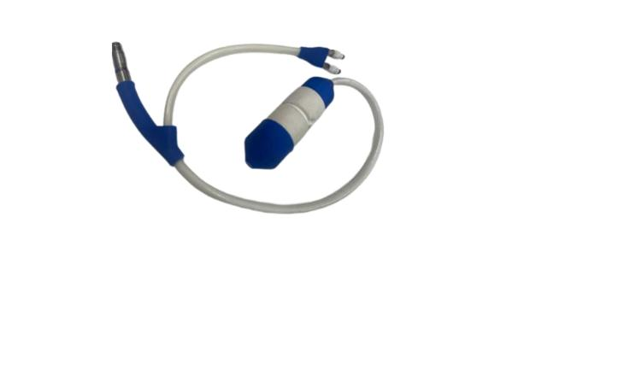

______________________________________________________________________________________________________________
•
•
Intralesional injections (e.g., collagenase, verapamil): Mixed results with significant
side effects, such as hematomas and penile rupture.
Surgery (e.g., plication, plaque excision): Effective for severe cases but invasive and
with risks of erectile dysfunction.
Advantages of LiESWT:
•
•
•
Non-invasive and painless.
Promotes neovascularization and softens plaques via macrophage activation.
Clinically proven to reduce plaque-related pain and improve curvature in some
cases.
•
No significant side effects with low-intensity applications.
4. Patient Selection Criteria
Inclusion Criteria:
•
•
•
•
•
Diagnosed with Peyronie’s Disease for more than 3 months but less than 12 months.
Penile curvature is between 30–90 degrees.
Single identifiable plaque.
Age 18–80 years.
No history of penile surgery.
Exclusion Criteria:
•
•
•
•
•
Penile curvature greater than 90 degrees.
Previous surgery for Peyronie’s Disease.
Patients with blood coagulation disorders.
Active lower urinary tract infections.
The presence of a medical device sensitive to electromagnetic radiation (e.g.,
pacemaker).
5. Pre-Treatment Screening
To determine the patient's suitability for LiESWT, conduct the following:
•
Comprehensive medical and sexual history review (trauma, plaque localization,
cohabitation issues).
•
Physical examination of the penile shaft for plaque palpation.

______________________________________________________________________________________________________________
•
•
Imaging: Use penile ultrasound to assess plaque size, location, and calcification.
Questionnaires: PDQ (Peyronie’s Disease Questionnaire) and IIEF to assess quality
of life and psychological impact.
6. Treatment Protocol
Preparation:
•
•
•
Conduct a thorough medical history and physical examination.
Counsel the patient about the procedure, benefits, risks, and expected outcomes.
Obtain written informed consent.
Procedure:
•
•
•
•
Number of Sessions: 6-10 sessions based on symptom severity.
Session Frequency: Twice per week.
Session Duration: 15 minutes.
Applications Per Session: 4 (two angles targeting the middle and sides of the
plaque).
•
•
Shocks Per Application: 500.
Total Shocks Per Session: 2,000.
Treatment Parameters:
•
•
Energy (HV) Settings: 2.0 kV.
Frequency (FRQ): 2.0 Hz.
Post-Treatment Care:
•
•
Advise patients to avoid sexual activity for 24 hours after each session.
Recommend hydration and report any adverse events.
7. Treatment Areas and Techniques
The treatment focuses on the following anatomical areas:
•
•
Dorsal and lateral sides of the penile shaft.
Plaque location (targeted at two angles).
Transducer Placement:
•
Palpate and identify plaque location.

______________________________________________________________________________________________________________
•
•
Position the transducer at a 15 mm coverage diameter and apply gentle pressure.
Administer 500 shocks per application area.
Adjustments by Severity:
1
.
Mild Plaques (Volume <1 cm³, curvature 30–45 degrees):
o
Apply standard protocol (2,000 shocks/session).
2
.
Moderate Plaques (Volume 1–3 cm³, curvature 45–70 degrees) and Severe
Plaques (Volume >3 cm³, curvature 70–90 degrees):
o
Consider applying 750 shocks per application (3,000 shocks/session).
8. Patient Comfort and Safety
To ensure patient comfort and safety during the procedure:
•
•
•
Position the patient supine with slight elevation of the pelvis for optimal access.
Use conductive gel to minimize discomfort and enhance shockwave transmission.
Monitor patient feedback during the session and adjust settings if necessary.
9. Treatment Outcomes and Follow-Up
Expected Results:
•
•
Pain reduction within 3-6 weeks.
Potential softening of plaques and reduction in penile curvature.
Follow-Up Visits:
•
Schedule bi-weekly follow-ups during the treatment period to monitor outcomes
and address concerns.
Long-Term Maintenance:
•
For sustained benefits, consider maintenance sessions every 6 months.
10. Quality Control
Device
Calibration:
•
•
Verify device settings before each session.
The MoreNova Device recognizes preprogrammed parameters to ensure accuracy.

______________________________________________________________________________________________________________
Clinician Training:
•
•
Ensure all operators are trained in the use of the MoreNova Device and C15 Transducer.
Clinicians should be familiar with this protocol and the "Instructions for Use"
provided by the manufacturer.
Checklist for Each Session:
•
•
•
•
Confirm that the patient meets inclusion criteria and has no contraindications.
Ensure the device and transducer are clean, sanitized, and functioning correctly.
Verify that transducer placement aligns with specified anatomical areas.
Fill with cold water and ensure during the treatment that the temperature stays in a
proper range.
11. Visuals and Diagrams
C15
•
Transducer placement technique and application angles.
12. References
For clinical studies and additional resources, visit the Initia Clinical Data Center.
